Nature Jumbo Toilet Roll

Product Code: | JTR302 |  | 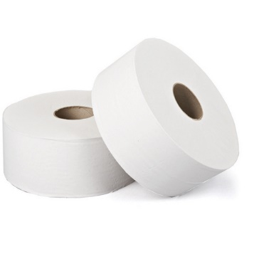
Date of issue: | 01/06/2023
Commodity Code: | 48030090
Country of Origin: | UK

Roll Specification |  |  | Pallet Specification
Paper Type: | Recycled |  | Cases per Layer: | 10
Colour: | White |  | Layer per Pallet: | 8
Ply: | 2 |  | Pallet Height: | 2.3m
Sheet Width: | 86mm |  | Cases per Pallet: | 80
Roll Length: | 300M |  | Double Stacked: | No
Core Diameter: | 60mm
Barcode: | 7342839835112

Case Specification |  |  | Accreditations
Case Quantity: | 6
Case Weight: | 4.6kg
Case Dimensions (WxLxH): | 230mm x 460mm x255mm
Packaging Material: | LDPE Shrink contains a minimum 30% PCR
Packaging Disposal: | Recycled board core and LDPE wrap, both can be widely recycled.

